**Appendix**

A1: **Figure 2.** Notes for user/developer meetings December 17th, 2014

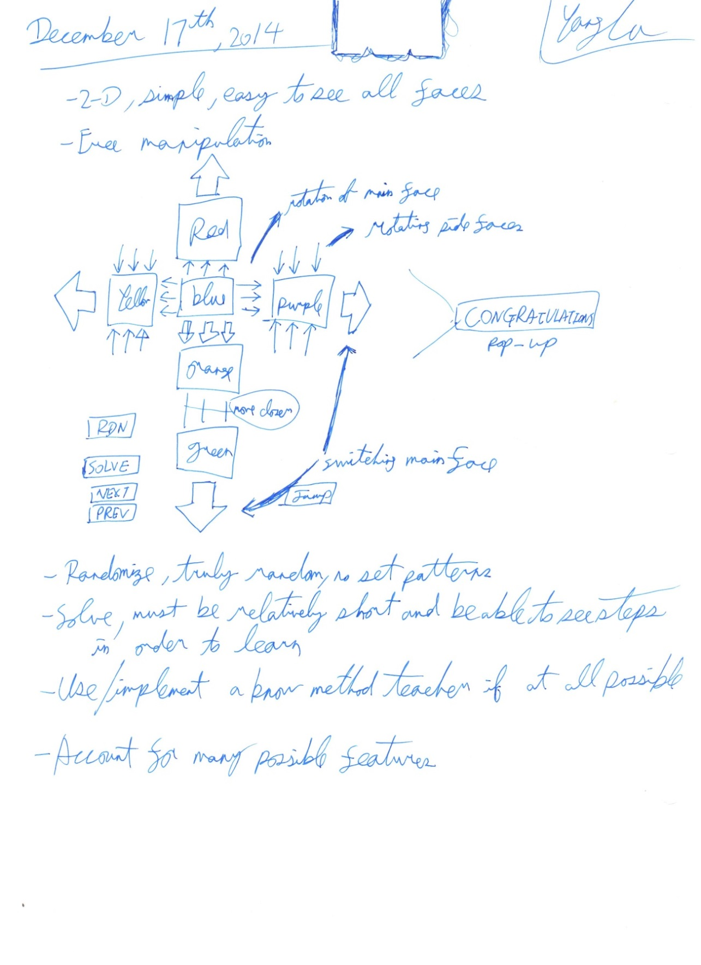

This was not typed up as it just serves the purpose to show the notes of development process. Typed versions can be requested, but they would not give any more insight in the program

A2: **Figure 3.** Notes for user/developer meetings December 28th, 2014

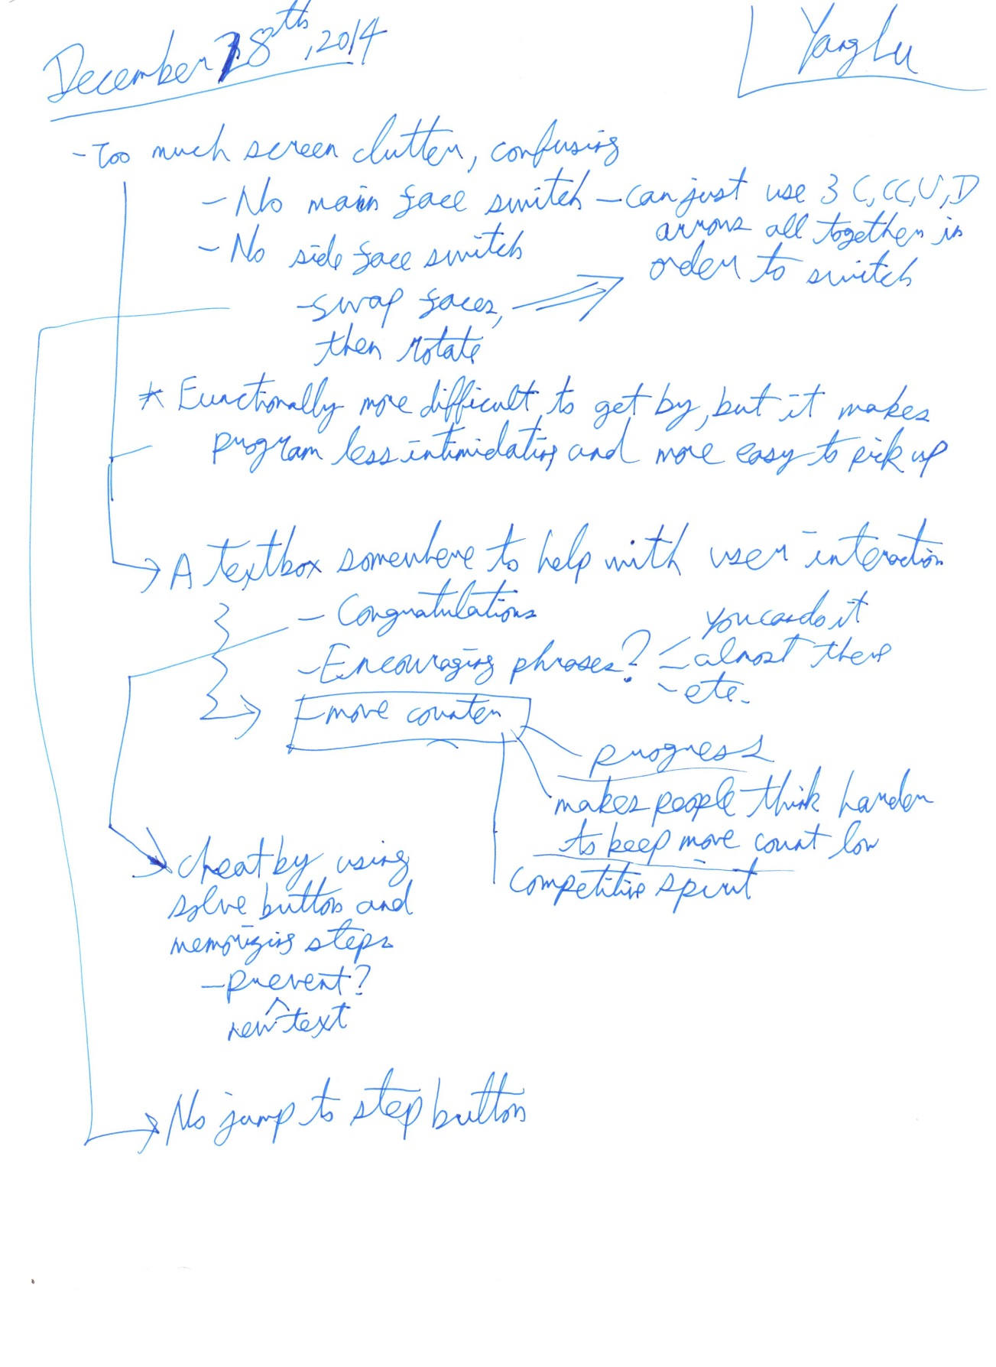

A3: **Figure 4.** Notes for user/developer meetings January 4th, 2015

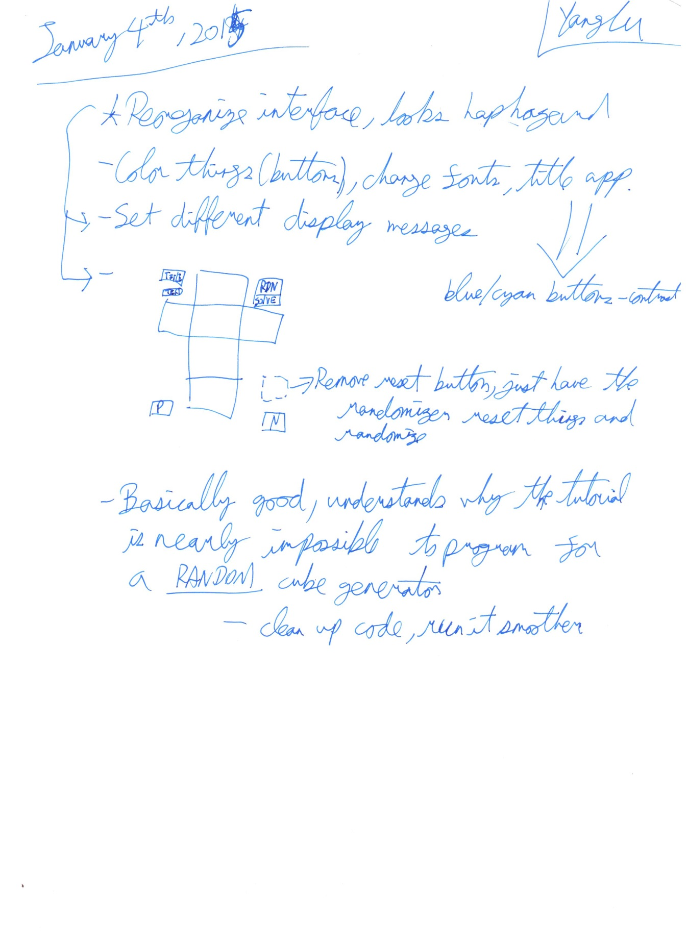

B: Word Count Table

**Table 4.** criterion with format, and recommended vs actual word count (sourced from IBO)

|  |  |  |  |  |
| --- | --- | --- | --- | --- |
| ***Criterion*** | ***Format*** | ***High Recommended Word Count*** | ***Actual Word Count*** | |
| **Planning** | | | | |
| Defining the problem or unanswered question | Extended writing | 250 | 189 | |
| Justification of proposed product | Extended writing | 250 | 215 | |
| Success Criteria | Bulleted list | n/a | 213 | |
| **Solution Overview** | | | | |
| Record of tasks | Form (table) | n/a | 226 | |
| Design overview | Diagrams, lists, tables | n/a | 532 | |
| **Development** | | | | |
| Developing the product | Extended writing | 1000 | 1049 | |
| **Functionality and Extensibility of Product** | | | | |
| Evidence of functionality | Video with possible paragraph | n/a | 84 | |
| Extensibility | Assessed otherwise | n/a | n/a | |
| **Evaluation** | | | | |
| Evaluation of the product | Extended writing | 250 | 255 | |
| Recommendations for futher development | Extended writing | 250 | 292 | |
|  |  |  |  | |
|  |  |  | No n/a | All |
| **Total** |  | **2000** | **2000** | **3055** |
|  |  |  |  | |
| Appendix | Additional information | n/a | Not evenly distributed, but it’s acceptable as overall word count meets the requiremments | |

C: References

"Computer Science Teacher Support Material." *Computer Science Teacher Support Material*. Web. 8 Jan. 2015. <https://ibpublishing.ibo.org/live-exist/rest/app/tsm.xql?doc=d_4_comsc_tsm_1201_1_e&part=4&chapter=4>.

(Word count table and flow chart)

"Computer Science Teacher Support Material." *Computer Science Teacher Support Material*. Web. 10 Jan. 2015. <https://ibpublishing.ibo.org/live-exist/rest/app/tsm.xql?doc=d_4_comsc_tsm_1201_1_e&part=4&chapter=2>.

(Sample Internal Assessment 1)

"Computer Science Teacher Support Material." *Computer Science Teacher Support Material*. Web. 3 Feb. 2015. <https://ibpublishing.ibo.org/live-exist/rest/app/tsm.xql?doc=d_4_comsc_tsm_1201_1_e&part=4&chapter=8>.

(Sample Internal Assessment 2)

"Computer Science Teacher Support Material." *Computer Science Teacher Support Material*. Web. 12 Feb. 2015. <https://ibpublishing.ibo.org/live-exist/rest/app/tsm.xql?doc=d_4_comsc_tsm_1201_1_e&part=4&chapter=9>.

(Stages for the process)

"Computer Science Teacher Support Material." *Computer Science Teacher Support Material*. Web. 15 Feb. 2015. <https://ibpublishing.ibo.org/live-exist/rest/app/tsm.xql?doc=d_4_comsc_tsm_1201_1_e&part=4&chapter=5>.

(Internal Assessment Criteria)

No Word Count Required for this Section